SAGE Math Test – Grades 5-6
Parents/LC’s: Please use this handout as a guide to go through the SAGE Math Practice test with your 5th or 6th grader. When I am asking the student to practice highlighting, strikethrough or reading a selection of the test we are just practicing test taking strategies. I want them to know how to use these tools, please help them understand the tools that are test taking strategy tools and the things that are actually part of answering a question.
Use this outline to practice “how-to” answer questions on the SAGE assessment:
#1) Click the answer choice and move on to the next question.
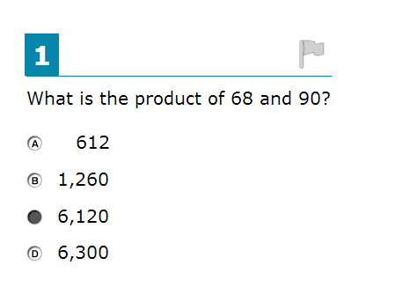
#2) Practice: Dragging and Dropping numbers into the blank fields. Also practice deleting a number or symbol you have chosen.
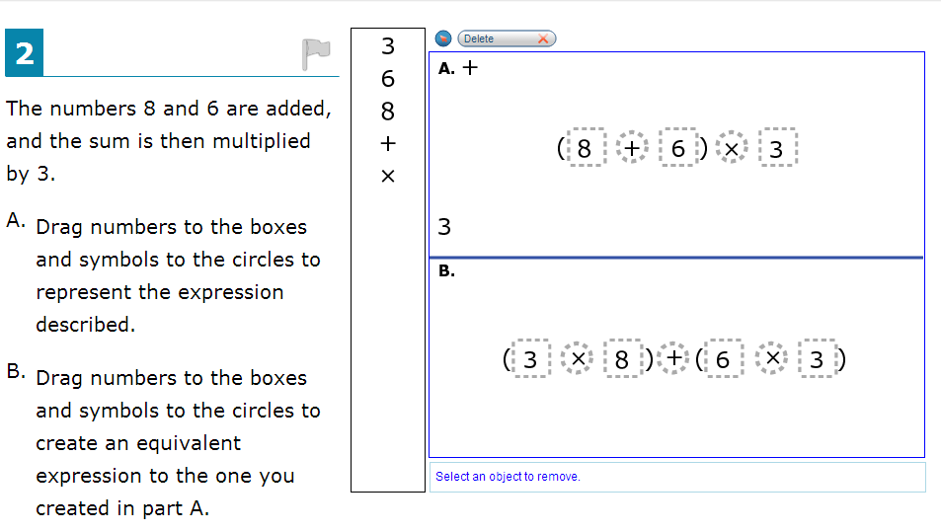

#3) Practice: use the highlighter tool to highlight the word “all”.(use the mouse to highlight the word “all” then right-click and select “highlight”. Why would it be helpful to use the highlighter tool on a tets?______________________________________________________________________________________________________________________________________________________________________ Practice: use the strikethrough tool to “strikethrough” answer choices you know are wrong. (use your mouse to highlight an answer choice you know is wrong and right click to select “strikethrough”. Why would it be helpful to use the strikethrough tool on a test?______________________________________________________________________________________________________________________________________________________________________
*NOTICE THAT THIS QUESTION HAS MULTIPLE ANSWERS!
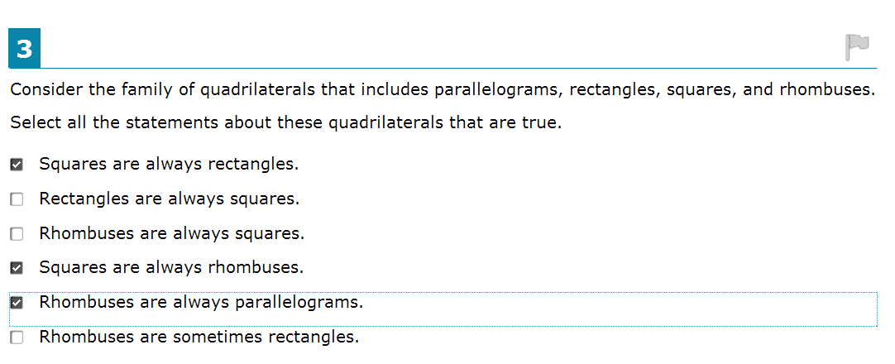
#4) Practice: Again, practice using your highlighter tool to highlight the words “At least”. Practice clicking the terrarium picture to change the level of soil.
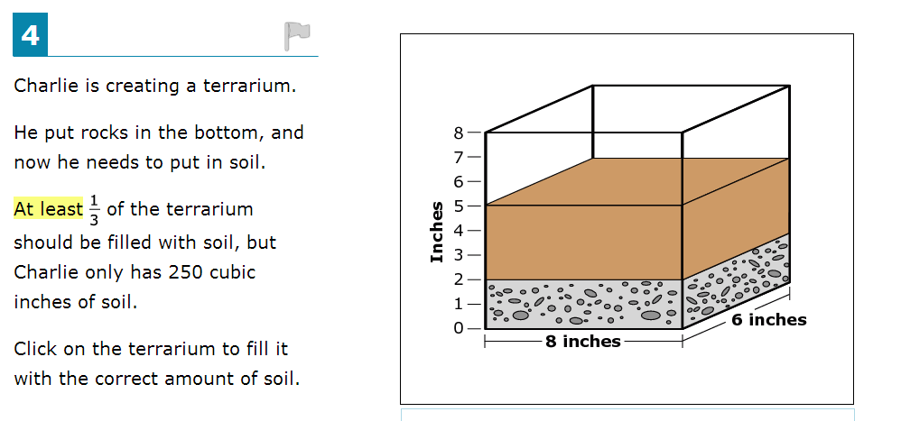

#5) Practice: Use your keypad and symbols to create an equation in the answer space. Practice: Use your Highlighter tool to highlight the words “Create an equation”
*If you are asked to “create an equation” then you will write a “number sentence” as your answer – not just a number.
TRUE FALSE
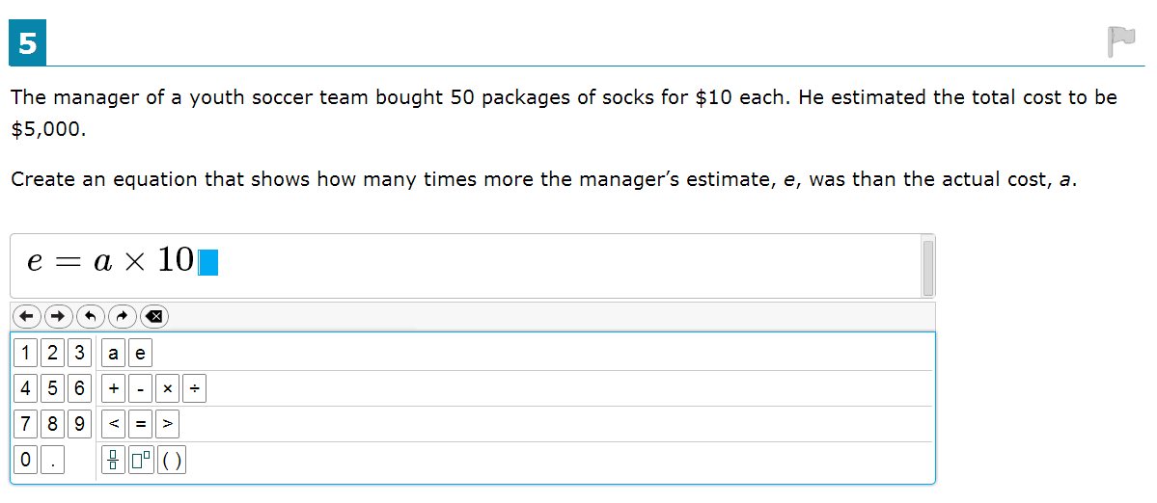
I answered through some of the next questions and didn’t check what number this one is: – do the same, answer through the next questions until you get to this one: Then practice using the tools as outlined below:
#?) Practice : Use the “Text to Speech” function. Use your mouse to highlight a portion of the question then right click and select “Speak Selection” Now use your keypad symbols to create and equation.
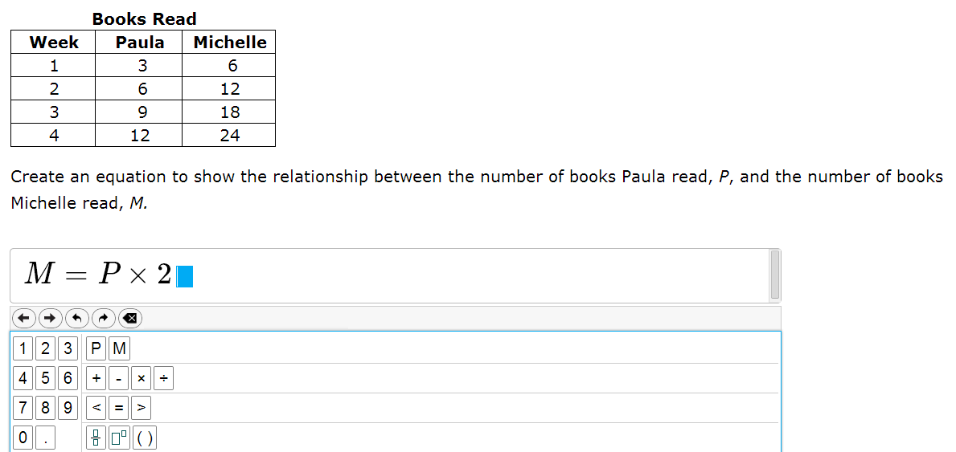

#?) Practice Answering in two answer space: Highlight the keyword “value” by selecting the word with your mouse and right clicking to select “highlight”. *When you are asked for the “value” of something you are being asked for a number – not an equation.
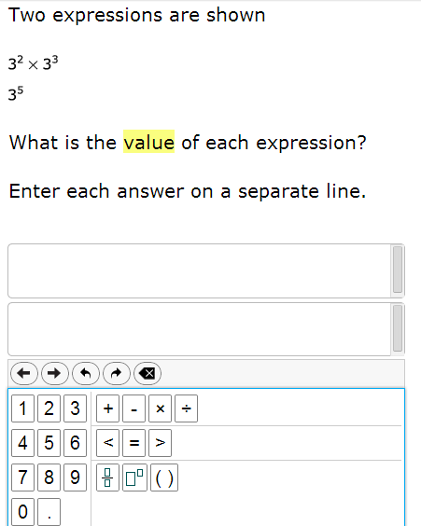
#10) Practice: Use the keypad to create an equation for the problem.
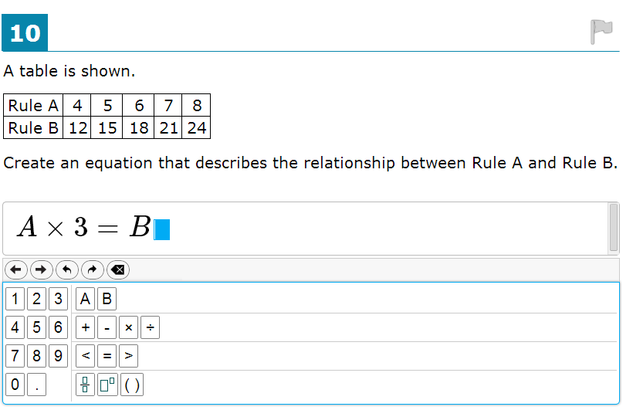

#11) Practice: Use the keypad to create two equations for the problem. Be sure to enter each one in a separate box. Also: Practice using the “flag” tool – this will allow you to come back and review this question at the end of the test. Just click on the flag in the upper right corner. Also notice how it “marks” the question in the dropdown list found in the top center portion of the screen
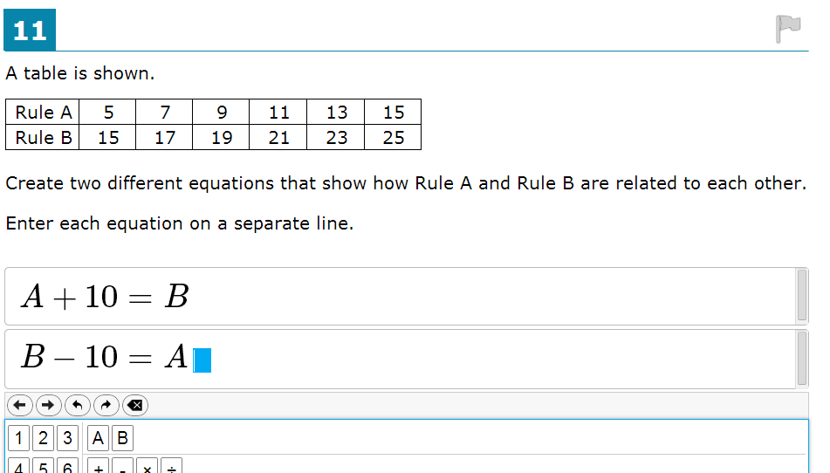

#12) Practice: Add data points. Practice answering this type of question.

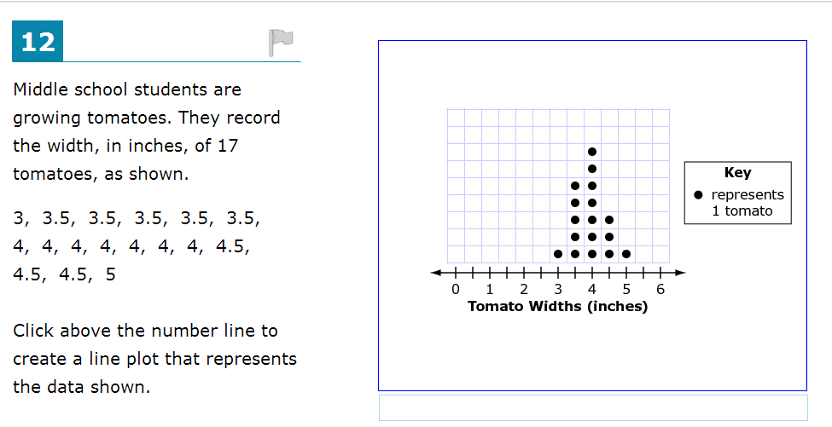

#13) Practice: Use the fraction symbol in the keypad to create a fraction for your answer. Remember to enter each answer on a separate line. Notice how a question like this can have many possible answers. There is not just one answer – you just need to make sure the answers you create make a true statement.
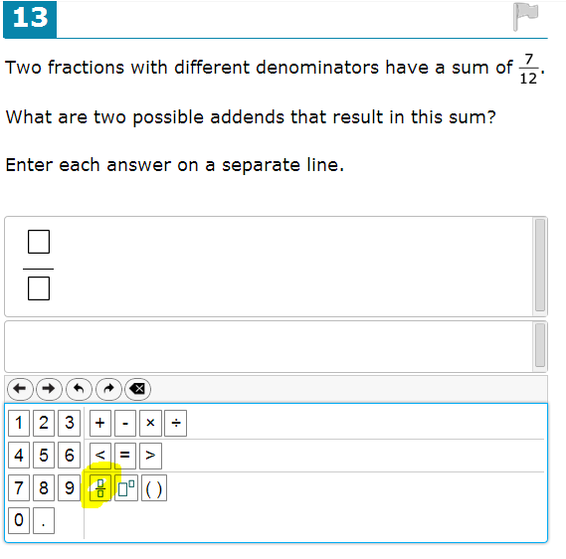
#14) Practice adding a point and deleting a point. You can also practice watching a tutorial on how to answer this type of question. To watch the tutorial, right-click menu or select the circular icon with an “I” inside of it. The tutorials do not have audio, and you can exit out of a tutorial at any time. 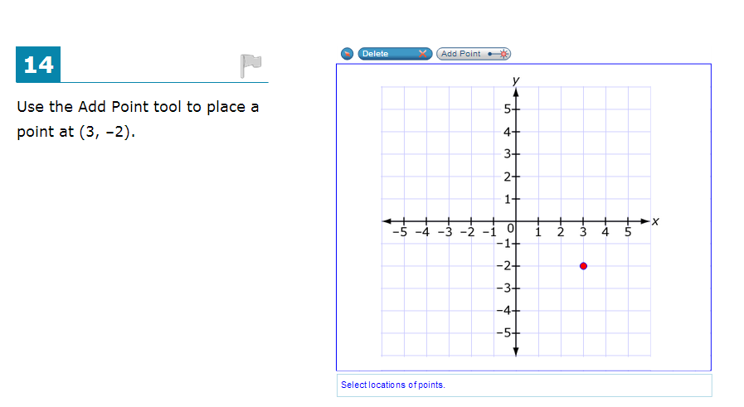

#15) Practice: Some questions will have multiple answers – select the correct answers and move on.
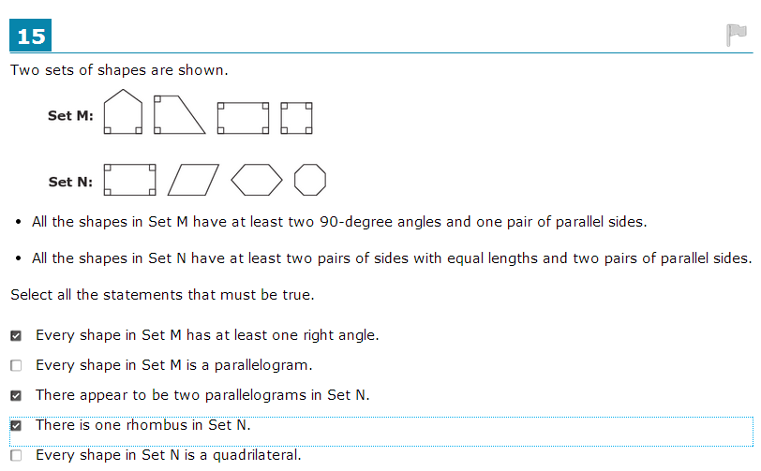

#16) Practice: Practice answering this type of question. Notice that there are 3 parts to this question. Also – notice that you can create the drawings anywhere in the space provided, just so long as the measurements are accurate.
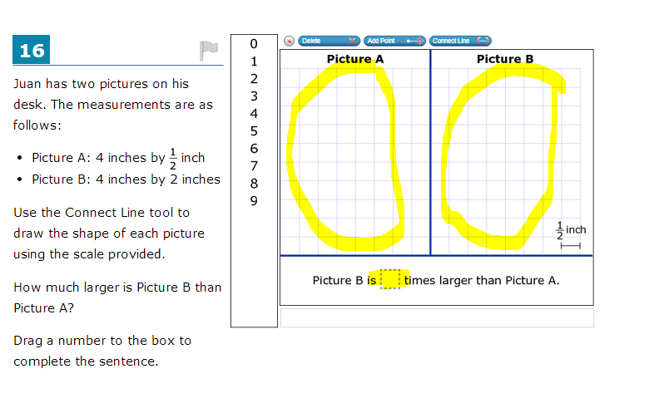
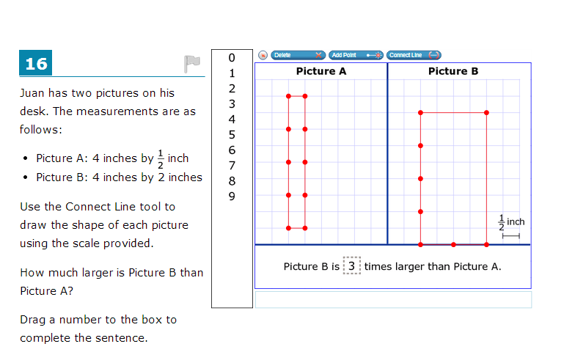

#17) Practice: Practice using the “Zoom In” and “Zoom Out” tools for these questions where you plot points. The zoom tools are located towards the top of the screen
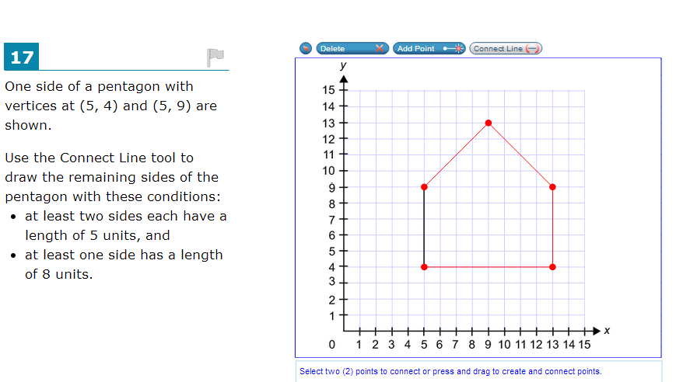
#18) Practice: Practice using the “Zoom In” and “Zoom Out” tools for these questions where you plot points. The zoom tools are located towards the top of the screen

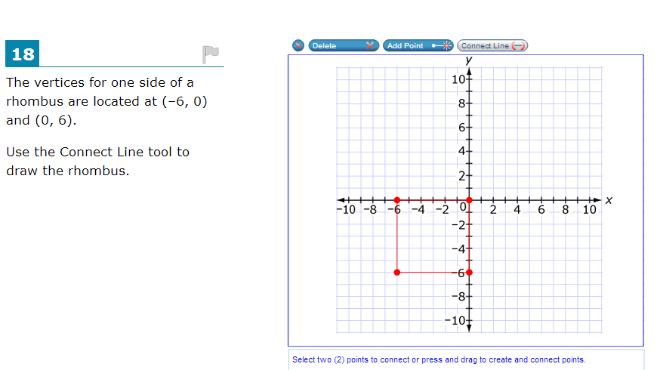

#19) Practice: Select the correct answer choice and move on to the next question.
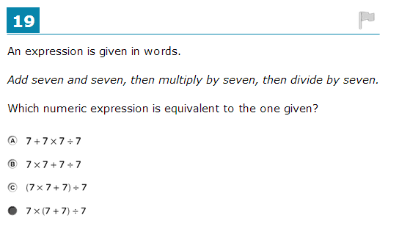

#20) Practice: Use your “zoom in” and “zoom out” tools. Use the Add Point and Connect Line functions to answer this question.
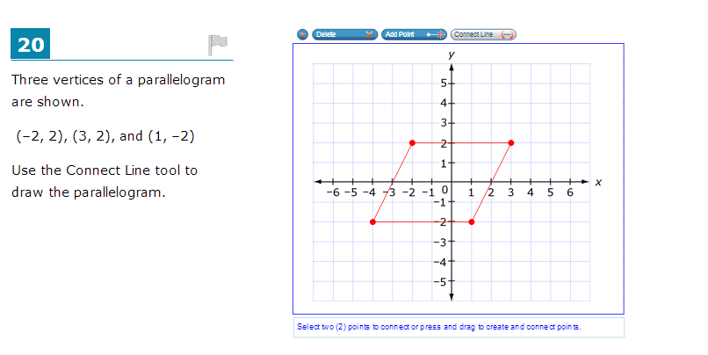
#23) Practice: answer this question by typing your response into the box. 