SAGE Practice Math 3-4
Parents/LC’s: Please use this handout as a guide to go through the SAGE Math Practice test with your 3rd or 4th grader. When I am asking the student to practice highlighting, strikethrough or reading a selection of the test we are just practicing test taking strategies. I want them to know how to use these tools, please help them understand the tools that are test taking strategy tools and the things that are actually part of answering a question.
#1) Practice: Click on your answer choice and move on to the next question.
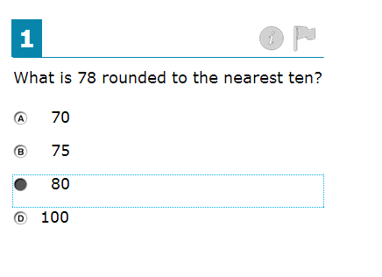
#2) Practice: Click on your answer choice. Then practice using the “Flag” tool. This will allow you to easily mark this question, so you can come back to it and check your work later. Just click on the “flag” icon above the question.
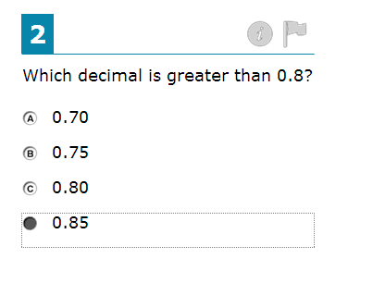
#3) Practice: Use the “Zoom In” and “Zoom Out” feature to make the grid larger. Practice using the “Add Point” and “Connect Line” tools to answer the question. *It doesn’t matter where in the grid the student creates the shape.
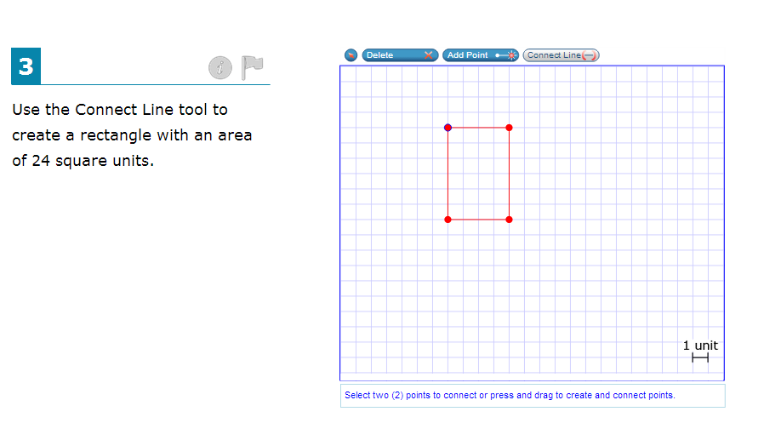
#4) Practice: Use the highlighter tool to highlight the word “equation”. To do this, use your mouse to select the word “equation” and then right-click to choose “highlight”. This is a test taking strategy, to help you remember what to do. When you create and equation, you are writing a “math sentence”.
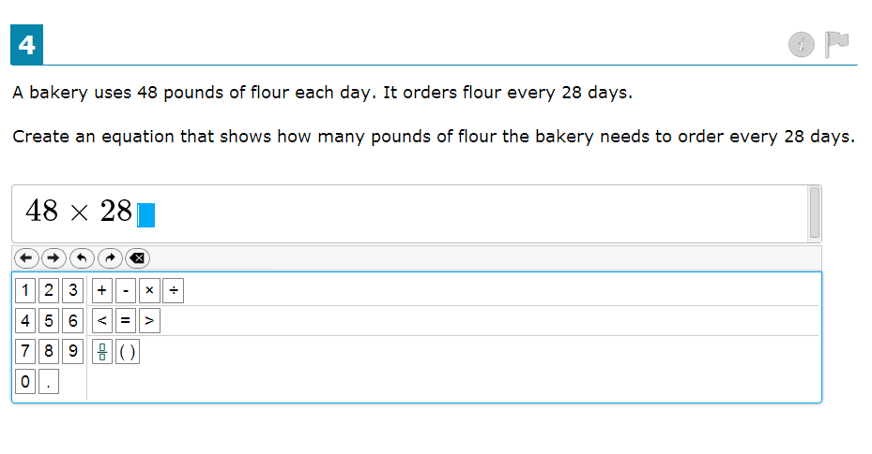

#5) Practice: Notice that there are multiple parts to this question. Practice answering this type of question by dragging and dropping symbols and numbers.
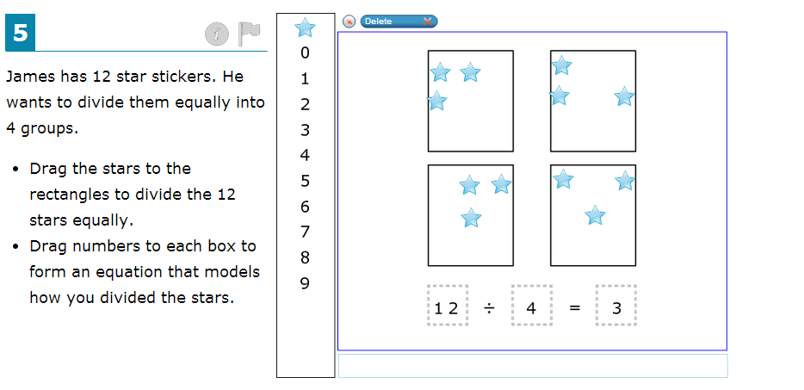

#6 and #7 – complete these questions and move on, to number 8.

#8) Practice: This question is asking you to “select all” select multiple correct answers. Practice the “read-aloud” feature by using your mouse to select the text, then right-click and choose “read”
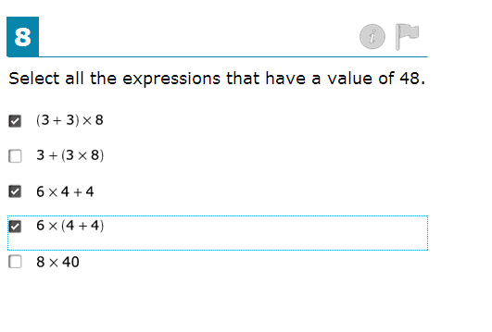

#9) Practice: click on the bar graph to create and alter the graph
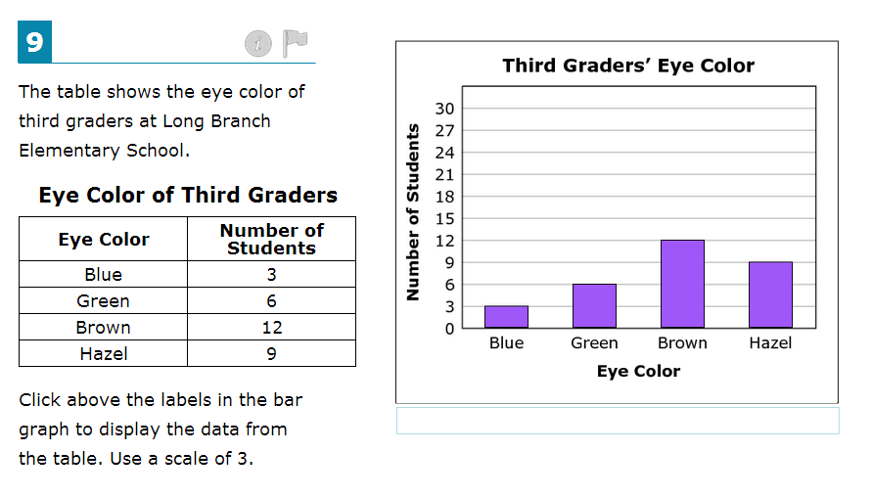
#10) Practice: Read the directions and the key carefully. Notice that one X is equal to 2 students. Practice clicking on the graph to represent the correct values. You can click on just half of an X to show 1 student. *Also, use drag and drop the numbers into the sentence at the bottom.
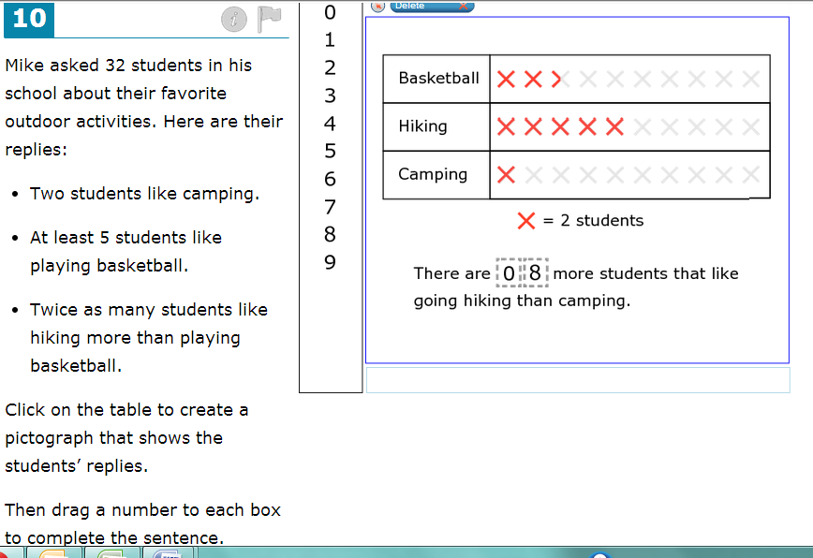

#11) Practice: This question has two parts. First you need to create an expression, that is write out a math sentence showing how you can solve the question. Then, in the next box, use the keypad to enter in the solution.
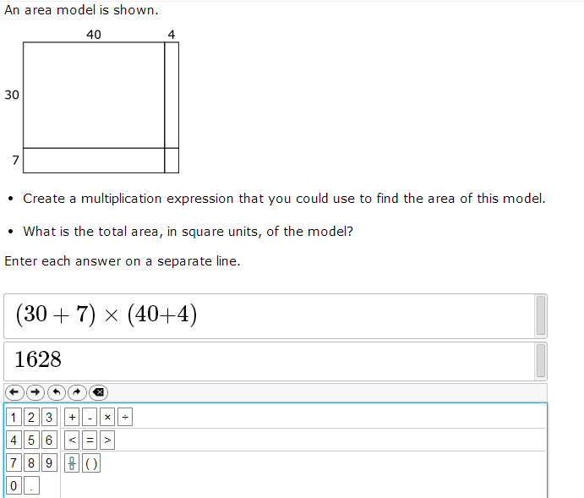
#12) Practice: use your mouse to click in a portion of the Pentagon to “shade”. Use the “delete” tool to practice deleting a shaded portion. Read through the question again and check to make sure you have answered all parts. Did you do B. and drag/drop numbers into the fraction at the bottom?
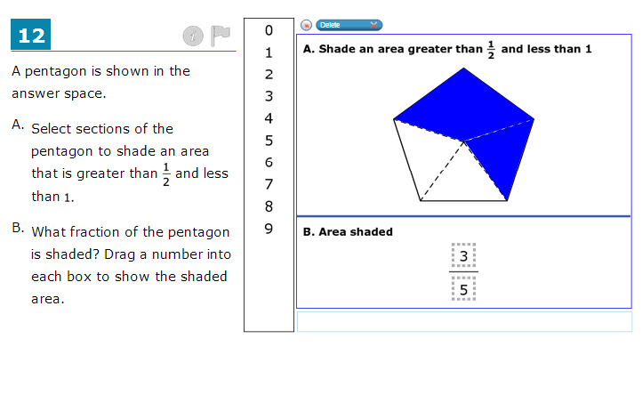
#13) Answer this question and move on to the next.

#14) Practice: Try out the tutorial feature – click on the “i – circle” icon next to the flag. This will start a tutorial on how to use your tools for this question. There is no audio in the tutorial. You can click out of the tutorial at any time. Now, answer part A by clicking on your choice. Use your “Add Point” and “Connect Line” tools to create the shape. *the shape can be created anywhere inside the grid
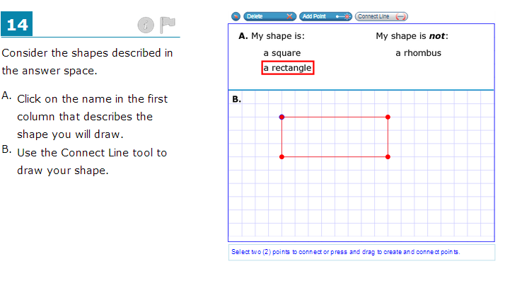
#15) Practice: Practice answering this type of question. *I did not answer this one and the “6” is not supposed to be in the grid. That is not the correct answer or the correct way to answer this question. What is the correct way?
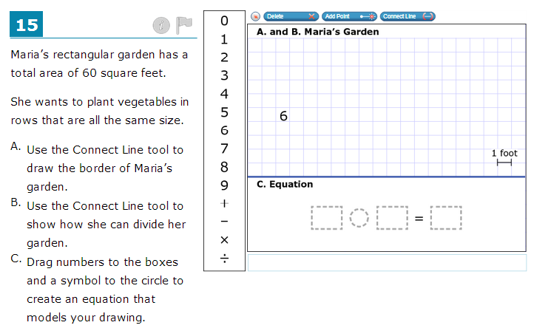

#16) Complete number 16 and move on to the next question.

#17) Practice: use your keyboard to type in a response to a question like this.
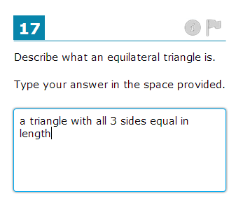
#18) Practice: Use your “Zoom In” feature to make the grid larger. Then use your Add Point tool to add points to the grid, answering the question. *I also used my highlighter feature, to help me remember and understand what I needed to do.
